CAr e aSt i vAe EDd i t oUr aLn dLD eAs i gHn e r

SKILLS
- Softskills
- Graphic Design
- Microsoft Office
- Basic Video Editing
- Basics of Information System
- WordPress+ Ai Web Developer
asadullah-my-portfolio.netlify.app

PERSONAL INFO
Father's Name: Abdullah
Data of Birth: 01/06/2005
Nationality: Pakistani
Religion: Islam
Marital Status: Single

OBJECTIVE
Secure a responsible career opportunity to fully utilize my training and skills, while making a significant contribution to the success of the Company

+923282628641

meer.asadullah2005@gmail.com Block II Ghazi Town Malir 15 Karachi

EXPERIENCE
01 Year experience in Graphic Designing
06 Months experience in Website Designing 06 Months experience in Data Entry
01 Year experience in typing Urdu & English
01 Year experience in Creative Marketing Services

LANGUAGES

EDUCATION

Intermediate. 2026
In Computer Science Ziauddin Board Karachi
From Ghazali Grammar Higher Secondary School
Sindhi

95%
Urdu

88%
Balochi

75%
English

68%

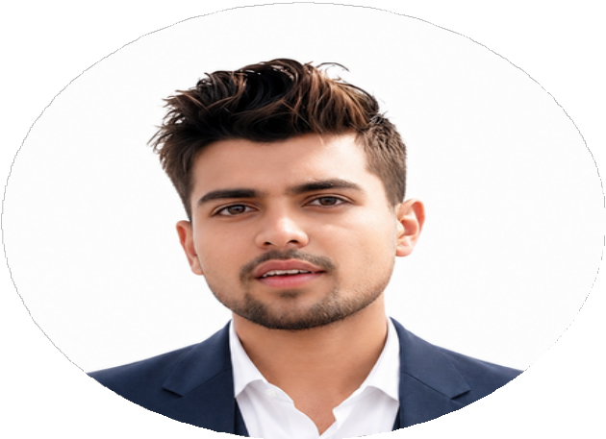







Diploma (DAE).  In Mechanical Engineering  From Government Polytechnic Institute Karachi | 2025
Matriculation  In Science  Board of Secondary Education Karachi | 2022
From Government Boys and Girls Secondary School ASU Village Malir

REFERENCE
Will be furnished on demand.

